**VISVESVARAYA TECHNOLOGICAL UNIVERSITY**

“JnanaSangama”, Belgaum-590014, Karnataka, India



A PROJECT PHASE REPORT ON

**“****Face recognition-based Attendance Management System”**

Submitted in partial fulfillment of the requirement of

**Final Project phase -II**

FOR THE SEVEN SEMESTER BACHELOR OF ENGINEERING DEGREE SUBMITTED BY

## TEJASVI JB 1IC16CS042

**UNDER THE GUIIDANCE OF**

## Prof. Hemavathi

DEPT. OF CS&E



IMPACT COLLEGE OF ENGINEERING AND APPLIED SCIENCES

SAHAKAR NAGAR, BANGALORE-560092

2020 -2021

IMPACT COLLEGE OF ENGINEERING AND APPLIED SCIENCES SAHAKARNAGAR, BANGALORE -560092

***DEPARTMENT OF COMPUTER SCIENCE AND ENGINEERING***

This is to certify that the project entitled “Face recognition-based Attendance Management System” carried out by **Mr. TEJASVI JB [1IC16CS042]**

Bonafede student of **Impact College Of Engineering And Applied Sciences** has been submitted in partial fulfillment of requirements in final Project Phase-III of VIII semester **Bachelor Of Engineering degree in Computer Science & Engineering** as prescribed by VISVESVARAYA TECHNOLOGICAL UNIVERSITY during the academic year of 2020-2021.

Signature of the Guide Signature of HOD Signature of Principal

**Prof. Hemavathi Prof. Rekha Dr. Khaleel Ahmed**



Name of Examiner Signature with date

1. 1.

2. 2.

**ABSTRACT**

Automatic face recognition (AFR) technologies have made many improvements in the changing world. Smart Attendance using Real-Time Face Recognition is a real-world solution which comes with day to day activities of handling student attendance system. Face recognition-based attendance system is a process of recognizing the students face for taking attendance by using face biometrics based on high - definition monitor video and other information technology. In my face recognition project, a computer system will be able to find and recognize human faces fast and precisely in images or videos that are being captured through a surveillance camera. Numerous algorithms and techniques have been developed for improving the performance of face recognition but the concept to be implemented here is Deep Learning. It helps in conversion of the frames of the video into images so that the face of the student can be easily recognized for their attendance so that the attendance database can be easily reflected automatically

**ACKNOWLEDGEMENT**

The satisfaction and euphoria that accompany the successful completion of any task would be incomplete without the mention of the people who made it possible and whose constant encouragement and guidance crowned our efforts with success.

I consider myself proud, to be part of **Impact College of Engineering And Applied Sciences** family, the institution which stood by our way in endeavours.

support.

I express my deep and sincere thanks to our Principal **Dr. Khaleel Ahmed** for his

I am grateful to Prof**. Rekha,** Professor and HOD, Dept of CS&E who is source of

inspiration and of invaluable help in channelizing my efforts in right direction.

I wish to thank my internal guide **Prof. Hemavathi**, Assistant Professor, Dept of CS&E for guiding and correcting various documents of mine with attention and care.

I would like to thank the faculty members and supporting staff of the Department of CS&E, ICEAS for providing all the support for completing the Project work.

Finally, I am grateful to my parents and friends for their unconditional support and help during the course of my Project work.

**Mr. TEJASVI JB [1IC16CS042]**

CONTENTS

## CHAPTER NO TITLE PAGE NO

1. INTRODUCTION 1
2. SCOPE OF THE PROJECT 2
   1. PROBLEM STATEMENT 2
   2. EXISTING SYSTEM 2
   3. PROPOSED SYSTEM 2-3
3. LITERATURE SURVEY 4-8
4. METHODOLOGY 9
   1. PROJECT METHODOLOGY 9 -10
   2. PLANNING 10 -11
   3. IMPLEMENTING 12
      1. RANDOM FORESTS 12
      2. SUPPORT VECTOR MACHINES 13- 14
      3. ADA BOOST 14
   4. ANALYSIS 15 -16
   5. FLOW CHART 16
5. SYSTEM REQUIREMENTS 17
   1. HARDWARE REQUIREMENTS 17
   2. SOFTWARE REQUIREMENTS 17

|  |  |  |
| --- | --- | --- |
| **FIGURE NO** | **TITLE** | **PAGE NO** |
| 1 | FACE DETECTION | 16 |
| 2 | NETWORK DIAGRAM | 17 |
| 3 | RECTANGLE FEATURES | 18 |
| 4 | RECTANGLE AREA COMPUTATION | 19 |
| 5 | FACE DETECTION BY HAAR CASCADE | 20 |
| 6 | FACE FEATURES RECOGNIZED BY ADA BOOST | 21 |
| 7 | EVALUATING ACCURACY FORMULA | 22 |
| 8  9 | FLOWCHART DIAGRAM  SNAPSHOTS | 23  24 |

**CHAPTER 1**

1. **INTRODUCTION**

A **facial recognition system** is a technology capable of matching a human face from a digital image or a video frame against a database of faces, typically employed to [authenticate](https://en.wikipedia.org/wiki/Authenticate) users through [ID verification services](https://en.wikipedia.org/wiki/ID_verification_service), works by pinpointing and measuring facial features from a given image.

While initially a form of computer [application](https://en.wikipedia.org/wiki/Application_software), facial recognition systems have seen wider uses in recent times on [smartphones](https://en.wikipedia.org/wiki/Smartphone) and in other forms of technology, such as [robotics](https://en.wikipedia.org/wiki/Robotics). Because computerized facial recognition involves the measurement of a human's physiological characteristics facial recognition systems are categorised as [biometrics](https://en.wikipedia.org/wiki/Biometrics). Although the accuracy of facial recognition systems as a biometric technology is lower than [iris recognition](https://en.wikipedia.org/wiki/Iris_recognition) and [fingerprint recognition](https://en.wikipedia.org/wiki/Fingerprint), it is widely adopted due to its contactless process.[[1]](https://en.wikipedia.org/wiki/Facial_recognition_system#cite_note-1) Facial recognition systems have been deployed in advanced [human-computer interaction](https://en.wikipedia.org/wiki/Human-computer_interaction), [video surveillance](https://en.wikipedia.org/wiki/Video_surveillance) and automatic [indexing](https://en.wikipedia.org/wiki/Search_engine_indexing) of images.[[2]](https://en.wikipedia.org/wiki/Facial_recognition_system#cite_note-:8-2)

The technology aims in imparting a tremendous knowledge oriented technical innovations these days. Deep Learning is one among the interesting domain that enables the machine to train itself by providing some datasets as input and provides an appropriate output during testing by applying different learning algorithms. Nowadays Attendance is considered as an important factor for both the student as well as the teacher of an educational organization. With the advancement of the deep learning technology the machine automatically detects the attendance performance of the students and maintains a record of those collected data. In general, the attendance system of the student can be maintained in two different forms namely, • Manual Attendance System (MAS) • Automated Attendance System (AAS). Manual Student Attendance Management system is a process where a teacher concerned with the particular subject need to call the students name and mark the attendance manually. Manual attendance may be considered as a time-consuming process or sometimes it happens for the teacher to miss someone or students may answer multiple times on the absence of their friends. So, the problem arises when we think about the traditional process of taking attendance in the classroom. To solve all these issues we go with Automatic Attendance System(AAS). The objective of this work is to propose an autism prediction model using ML techniques and to develop a mobile application that could effectively predict autism traits of an individual of any age. In other words, this work focuses on developing an autism screening application for predicting the ASD traits among people of age groups 4-11 years, 12-17 years and for people of age 18 and more. Automated Attendance System (AAS) is a process to automatically estimate the presence or the absence of the student in the classroom by using face recognition technology. It is also possible to recognize whether the student is sleeping or awake during the lecture and it can also be implemented in the exam sessions to ensure the presence of the student. The presence of the students can be determined by capturing their faces on to a high-definition monitor video streaming service, so it becomes highly reliable for the machine to understand the presence of all the students in the classroom. The two common Human Face Recognition techniques are,

• Feature-based approach

• Brightness-based approach.

The Feature-based approach also known as local face recognition system, used in pointing the key features of the face like eyes, ears, nose, mouth, edges, etc., whereas the brightness-based approach also termed as the global face recognition system, used in recognizing all the parts of the image.

# CHAPTER 2

1. **SCOPE OF THE PROJECT**

## Problem Statement

The main objective of this project is to offer **system** that simplify and automate the process of recording and tracking student’s **attendance** through **face recognition** technology. It is biometric technology to identify or verify a person from a digital image or surveillance video.

## Existing System

**Fingerprint Based recognition system:**

In the Fingerprint based existing attendance system, a portable fingerprint device need to be configured with the students fingerprint earlier. Later either during the lecture hours or before, the student needs to record the fingerprint on the configured device to ensure their attendance for the day. The problem with this approach is that during the lecture time it may distract the attention of the students.

**RFID(Radio Frequency Identification) Based recognition system:**

In the RFID based existing system, the student needs to carry a Radio Frequency Identity Card with them and place the ID on the card reader to record their presence for the day. The system is capable of to connect to RS232 and record the attendance to the saved database. There are possibilities for the fraudulent access may occur. Some are students may make use of other student’s ID to ensure their presence when the particular student is absent or they even try to misuse it sometimes

### 

### Disadvantages of Existing System:

**The existing system has difficulties in recognizing:**

* Out of plane rotation: frontal,45degree, profile, upside down
* Presence of beard, mustache, glasses etc.
* Facial expressions
* Image conditions
* Size
* Lighting condition
* Distortion
* Noise
* Compression

## Proposed System

The task of the proposed system is to capture the face of each student and to store it in the database for their attendance. The face of the student needs to be captured in such a manner that all the feature of the students' face needs to be detected, even the seating and the posture of the student need to be recognized. There is no need for the teacher to manually take attendance in the class because the system records a video and through further processing.

### Advantages of Proposed System:

* + - Don’t have to figure out the features ahead of time.
    - More effective.
    - Fault tolerant.
    - Scales well.

# CHAPTER 3

1. **LITERATURE SURVEY**

## A Counterpart Approach to Attendance and Feedback System using Machine Learning Techniques

N.Sudhakar Reddy, 2 M.V.Sumanth, 3S.Suresh Babu 123Assistant Professor,SRK Institute of Technology,Enikapadu,Vijayawada

## Abstract

Education is one of the wisest aspects that is required to everyone in this country. In this regard as technology widens its width and length especially the paper work is replaced with the technology. As machine learning is one of the domains that deals with the both aspects we need a system that coordinate with the technology which reduces the human effort. Here in this paper we have mentioned an idea that combines two technologies with machine learning approaches. As the technology is imparting its roots towards the knowledge technological interventions are being developed now a days. Out of which machine learning is one of the important domains that makes the learning through machines by giving some input and obtaining the output from the given input. Education is the key to open a door called knowledge and it’s the weapon to make it a progressive representation and in India educational system consists of only the manual work and now a days with the advancement of technologies like machine learning it’s the system that automatically detects the student performance and attendance Maintenance of student records like attendance and his feedback on the subjects like Maths,English in the school level as well as his records of feedbacks in Engineering colleges is also a difficult measure therefore a system that deserves all the elements of the student level from the scratch is being made available now a days and it has been implemented by recognizing his face his attendance details must be displayed and by his face he can automatically give his attendance as well as his feedback all at once.

## Face Recognition Based Attendance System

Nandini R, Duraimurugan N, S.P.Chokkalingam

## Abstract

Automatic face recognition (AFR) technologies have made many improvements in the changing world. Smart Attendance using Real-Time Face Recognition is a real-world solution which comes with day to day activities of handling student attendance system. Face recognition-based attendance system is a process of recognizing the students face for taking attendance by using face biometrics based on high - definition monitor video and other information technology. In my face recognition project, a computer system will be able to find and recognize human faces fast and precisely in images or videos that are being captured through a surveillance camera. Numerous algorithms and techniques have been developed for improving the performance of face recognition but the concept to be implemented here is Deep Learning. It helps in conversion of the frames of the video into images so that the face of the student can be easily recognized for their attendance so that the attendance database can be easily reflected automatically.

## Face recognition: A literature survey

Cheol-Hong Min, 2017, W. Zhao, R. Chalupa , P.J Phillips

## Abstract

As one of the most successful applications of image analysis and understanding, face recognition has recently received significant attention, especially during the past several years. At least two reasons account for this trend: the first is the wide range of commercial and law enforcement applications, and the second is the availability of feasible technologies after 30 years of research. Even though current machine recognition systems have reached a certain level of maturity, their success is limited by the conditions imposed by many real applications. For example, recognition of face images acquired in an outdoor environment with changes in illumination and/or pose remains a largely unsolved problem. In other words, current systems are still far away from the capability of the human perception system.This paper provides an up-to-date critical survey of still- and video-based face recognition research. There are two underlying motivations for us to write this survey paper: the first is to provide an up-to-date review of the existing literature, and the second is to offer some insights into the studies of machine recognition of faces. To provide a comprehensive survey, we not only categorize existing recognition techniques but also present detailed descriptions of representative methods within each category. In addition, relevant topics such as psychophysical studies, system evaluation.

* 1. **Literature survey on face and face expression recognition**

[J Anil](https://ieeexplore.ieee.org/author/37085856125); [L. Padma Suresh](https://ieeexplore.ieee.org/author/37085863417)

**Abstract:**

Face Expression Recognition (FER) has become a very interesting and challenging area in computer vision field due to its wide application possibilities. Mental state Recognition, Human Computer Interaction, Human behavior understanding etc. are some of its applications. Because of its wide application possibilities Face expression recognition has attained a very crucial role in the area of facial image processing. In this paper some of the tailor-made face expression Recognition algorithms are presented. This paper also gives a brief insight into the feature extraction method of these face expression recognition techniques. The features extraction technique plays a crucial role in the efficiency of these algorithms. In this paper a few Face Expression Recognition techniques like Patched Geodesic Texture Transform, Curvelet Feature Extraction, Bag of Words Method, Local Directional Number Pattern, Regional Registration Technique, Gradient Feature Matching etc. which are used to recognize the facial expression are presented.

# CHAPTER 4

1. **METHODOLOGY**

## Project Methodology

## 

## Student Feedback System

## Student Attendance Experimental Design

As the technology is imparting its roots towards the knowledge technological interventions are being developed now a days. Out of which machine learning is one of the important domains that makes the learning through machines by giving some input and obtaining the output from the given input. Education is the key to open a door called knowledge and it’s the weapon to make it a progressive representation and in India educational system consists of only the manual work and now a days with the advancement of technologies like machine learning it’s the system that automatically detects the student performance and attendance Maintenance of student records like attendance and his feedback on the subjects like Maths, English in the school level as well as his records of feedbacks in Engineering colleges is also a difficult measure therefore a system that deserves all the elements of the student level from the scratch is being made available now a days and it has been implemented by recognizing his face his attendance details must be displayed and by his face he can automatically give his attendance as well as his feedback all at once.

**Dataset**

Student feedback can be collected using mobile phones, social media and in form of responses to questions in a single sentence, from students who posted their views in online discussion forums.

**Evaluation Measures**

• Accuracy: Accuracy in classification problems is the number of correct predictions made by the model over all kind’s predictions made.

**Face Recognition**

• **Face Detection**

Facial detection is one of the elements of identifying the student record with his identity or the personal recognition where they can probe through detection

**•** **Face Recognition –**

Identity of the person through his number or name is the first phase where a student can get the record of the student by recognizing the face of the student Facial recognition is followed by the facial identification where a student’s identity can be accessed followed by gathering the attendance record.

**Student Feedback System**

**Step 1**: **Data collection**

Capturing the data from the various sources is also a challenging task and it is done by machine learning with the combination of his attendance identity

**Step 2: Data Preprocessing**

The data that is captured from facial recognition and facial identification is preprocessed

**Step 3: Extraction of Feature Set/Training Data**

After the captured data is preprocessed a training data set is extracted from the preprocessed data

**Step 4: Implementation of Machine Learning Algorithm on Feature Set/Training Data** Developing a record of set of machines learning existing algorithms to form a new algorithm that is composed of all the data sets

**Step 5: Testing on Datasets**

The data that is tested on the data sets

**THE NEW INNOVATION**

With this experiment we can concrete two aspects of learning one is the learning technique that acts according to the choice and the other one is the voice that acts according to the learners input.In the learning techniques especially with regard to the machine learning the characteristics of the learner must be able to understand the outcomes when the learner is giving it as an input

**ATTENDANCE**

The attendance is going to get captured via the biometric and it is made available as soon as the student and it is to be submitted as soon as the student comes into the classroom the biometric finger print of the student is sent to the parent directly. Whenever a student comes to the college his biometric fingerprint is captured and it is to processed via biometric device and the finger print is captured and it is stored in the computer

**ROLE OF MACHINE LEARNING**

The major role of machine learning starts from here where a system recognized the finger print of the student the student data is to be captured and the characteristics of the student must be analyzed based on the finger print of the student. This sort of new technology evolving now a days is a bit new and new to do it as a proposal this enhancement is to be made easier and it is to get processed. In order to identify the characteristics of the student via finger print may not be available due to the immense technological development this technology may occur in future in the recent enhanced technological developments and now it is the turn to develop that sort of technological interventions as technology is changing its root day by day.

The following is the methodology in order to bring that sort of technological interventions

* Data preprocess
* Data Analysis
* Data Enrichment
* Data Prediction

This process is called as PAEP Process and this is the new name given to this technology

**Data Preprocess**

In this type of technology, the attendance of the student is captured via fingerprint and the device to capture the attendance is to be made available first.

**Data Analysis**

In this type of process the data that is captured needed to get analyzed and this analysis is happened only because the attendance that is captured is analyzed based on the number of days a student is going to attend the classes is to be analyzed and enhanced and it is to be sent to the next phase

**Data Enrichment**

This is a sort of correcting the data that is analyzed and to be enhanced via the testing phase and the enriched data is sent to the next phase

**Data Prediction**

This is one kind of predicting the data that is right and that is the conduct of the student the conduct of the student is measured based on the number of days the student is going to attend the class work via his attendance and it is predicted in this phase. The conduct display of the student is displayed in number of days the student is going to present and it is displayed for every week. This sort of technology makes the student to understand the importance of attendance in the level of school as well as the level of college in order to fulfill his grades especially in order to improve his conduct. As conduct certificate is one of the important certificates that is necessary for every student to act and study higher levels of education Before collecting the feedback of the student records there is need to identify the behavior of the student based on the characteristics of the student performance prediction this era can be easily resolved.

**Facial recognition**

The technique of image processing aligned with machine learning is implied here as here there are two sort of outcomes in this project one is his feedback and the feedback how it helps in improving the performance of the student record.Facial Identification Facial identification is the record to identify and verify whether the student coming to college with specific roll number is verified and make it as an identifying priority to the system

**Facial Characteristics prediction**

Based on the facial data his/her characteristics are needed to get predicted automatically by the system following the image processing technique as image processing is capturing the image based on the several set of images a machine is given as an input following the four parameters

* Good
* Bad
* Average
* Above Average

These parameters are given to the system once and later the student performance analysis is going to get probed in the marks he/she performed in the exams and this is to be enhanced and make it a progressive measure and it is trained via training data in the system.So the student record burdens that are written manually in the present system are upgraded to a simple app so they can get the student record every time.

**FEEDBACK SYSTEM**

**Step 1: Data collection**

Capturing the data from the various sources is also a challenging task and it is done by machine learning with the combination of his attendance identity

**Step 2: Data Preprocessing**

The data that is captured from facial recognition and facial identification is preprocessed

**Step 3: Extraction of Feature Set/Training Data**

After the captured data is preprocessed a training data set is extracted from the preprocessed data

**Step 4: Implementation of Machine Learning Algorithm on Feature Set/Training Data** Developing a record of set of machine learning existing algorithms to form a new algorithm that is composed of all the data sets

**Step 5: Testing on Datasets**

The data that is tested on the data sets

## Planning

To identify all the information and requirement such as hardware and software, planning must be done in the proper manner. The planning phase has two main elements namely data collection and the requirements of hardware and software.

### Data collection:

Machine learning needs two things to work, data (lots of it) and models. When acquiring the data, be sure to have enough features (aspect of data that can help for a prediction, like the surface of the house to predict its price) populated to train correctly your learning model. In general, the more data you have the better so make to come with enough rows.

The primary data collected from the online sources remains in the raw form of statements, digits and qualitative terms. The raw data contains error, omissions and inconsistencies. It requires corrections after careful scrutinizing the completed questionnaires. The following steps are involved in the processing of primary data. A huge volume of raw data collected through field survey needs to be grouped for similar details of individual responses.

Data Preprocessing is a technique that is used to convert the raw data into a clean data set. In other words, whenever the data is gathered from different sources it is collected in raw format which is not feasible for the analysis.

**Capture photo:**

The Camera is fixed at a specific distance inside a classroom to capture photos of the frontal images of the entire students of the class

**Face Detection:**

Face Detection is the process where the image, given as an input (picture) is searched to find any face, after finding the face the image processing cleans up the facial image for easier recognition of the face. CNN algorithm can be implemented to detect the faces

**Face Recognition:**

After the completion of detecting and processing the face, it is compared to the faces present in the students' database to update the attendance of the students.

The post-processing mechanism involves the process of updating the names of the student into an excel sheet. The excel sheet can be maintained on a weekly basis or monthly basis to record the students' attendance. This attendance record can be sent to parents or guardians of students to report the performance of the student.

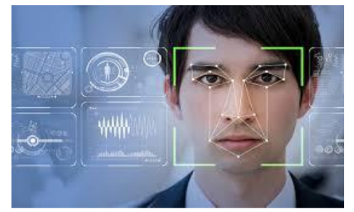

Fig 4.1: Face recognition

**NETWORK DIAGRAM:**

A CNN (Convolution Neural Network) uses a system like a multilayer perceptron that has been designed to process the requirements faster. The CNN layer consist of an input layer, an output layer and a hidden layer that includes multiple convolution layers, pooling layers, fully connected layers, and normalization layers. The removal of limitations and increase in efficiency for image processing results in a system that is far more effective, simpler to trains limited for image processing and natural language processing.

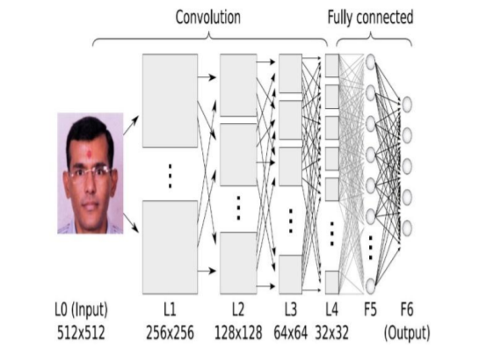

Fig 4.2 : Network Diagram

## Implementing

## The Viola/Jones Face Detector

## Object Detection is a computer technology related to computer vision, image processing and deep learning that deals with detecting instances of objects in images and videos. A widely used method for real-time object detection. Training is slow, but detection is very fast.

## An extremely fast face detector will have broad practical applications. These include user interfaces, image databases, and teleconferencing. In applications where rapid frame-rates are not necessary, our system will allow for significant additional post-processing and analysis. In addition our system can be implemented on a wide range of small low power devices, including hand-helds and embedded processors.

## Features

## Our object detection procedure classifies images based on the value of simple features. There are many motivations ure. for using features rather than the pixels directly. The most common reason is that features can act to encode ad-hoc domain knowledge that is difficult to learn using a finite quantity of training data. For this system there is also a second critical motivation for features: the feature based system operates much faster than a pixel-based system.

## 

## Figure 4.3 : Example rectangle features shown relative to the enclosing detection window. The sum of the pixels which lie within the white rectangles are subtracted from the sum of pixels in the grey rectangles. Two-rectangle features are shown in (A) and (B). Figure (C) shows a three-rectangle feature, and (D) a four-rectangle feature.

## The simple features used are reminiscent of Haar basis functions which have been used by Papageorgiou et al. [10]. More specifically, we use three kinds of features. The value of a two-rectangle feature is the difference between the sum of the pixels within two rectangular regions. The regions have the same size and shape and are horizontally or vertically adjacent (see Figure 1). A three-rectangle feature computes the sum within two outside rectangles subtracted from the sum in a center rectangle. Finally, a four-rectangle feature computes the difference between diagonal pairs of rectangles. Given that the base resolution of the detector is 24x24, the exhaustive set of rectangle features is quite large, over 180,000. Note that unlike the Haar basis, the set of rectangle features is overcomplete.

**Integral Image**

Rectangle features can be computed very rapidly using an intermediate representation for the image which we call the integral image. The integral image at location contains the sum x, y contains the sum of the pixels above and to the left of x, y, inclusive:

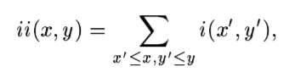

Where ii(x, y) is the integral image and i(x, y) is the original image. Using the following pair of recurrences.

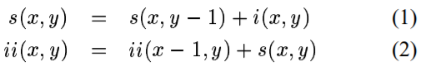

(where s(x, y) is the cumulative row sum, s(x, -1) = 0, and ii(-1, y) = 0) the integral image can be computed in one pass over the original image. . Using the integral image any rectangular sum can be computed in four array references (see Figure 2). Clearly the difference between two rectangular sums can be computed in eight references. Since the two-rectangle features defined above involve adjacent rectangular sums they can be computed in six array references, eight in the case of the three-rectangle features, and nine for four-rectangle features.

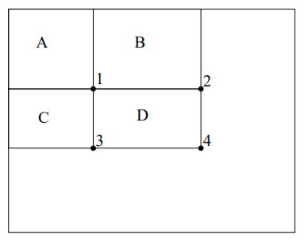

Figure 4.5: The sum of the pixels within rectangle D can be computed with four array references. The value of the integral image at location 1 is the sum of the pixels in rectangle A. The value at location 2 is A + B, at location 3 is A + C, and at location 4 is A + B + C + D, The sum within D can be computed as 4 + 1 – ( 2+ 3)

**Feature Discuss**

Rectangle features are somewhat primitive when compared with alternatives such as steerable filters [5, 7]. Steerable filters, and their relatives, are excellent for the detailed analysis of boundaries, image compression, and texture analysis. In contrast rectangle features, while sensitive to the presence of edges, bars, and another simple image structure, are quite coarse. Unlike steerable filters the only orientations available are vertical, horizontal, and diagonal. The set of rectangle features do however provide a rich image representation which supports effective learning. In conjunction with the integral image, the efficiency of the rectangle feature set provides ample compensation for their limited flexibility

## 

## Example Classifier for Face Detect

A classifier with 200 rectangle features was learned using AdaBoost 95% correct detection on test set with 1 in 14084 false positives. Not quite competitive...

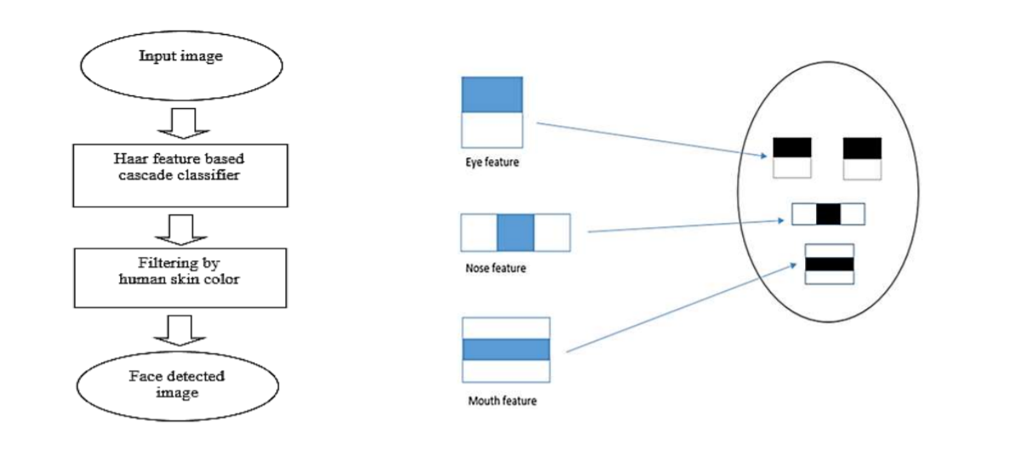

Fig 4.6: Face detection by Haar Cascade

## Ada Boost

Ada Boost is one of the first boosting algorithms to be adapted in solving practices. Ada Boost helps you **combine multiple “weak classifiers” into a single “strong classifier”**. Here are some (fun) facts about Ada boost ! While details on the training and performance of the final system are presented in Section 5, several simple results merit discussions. Initial experiments demonstrated that a frontal face classifier constructed from 200 features yields a detection rate of 95% with a false positive rate of 1 in 14084. These results are compelling, but not sufficient for many real-world tasks. In terms of computation, this classifier is probably faster than any other published system, requiring 0.7 seconds to scan an 384 by 288 pixel image. Unfortunately, the most straightforward technique for improving detection performance, adding features to the classifier, directly increases computation time. For the task of face detection, the initial rectangle features selected by AdaBoost are meaningful and easily interpreted. The first feature selected seems to focus on the property that the region of the eyes is often darker than the region e. of the nose and cheeks (see Figure 3). This feature is relatively large in comparison with the detection sub-window, and should be somewhat insensitive to size and location of the face. The second feature selected relies on the property that the eyes are darker than the bridge of the nose.

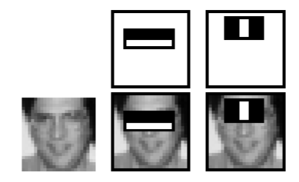

Figure 4.7: The first and second features selected by AdaBoost. The two features are shown in the top row and then overlayed on a typical training face in the bottom row. The first feature measures the difference in intensity between the region of the eyes and a region across the upper cheeks. The feature capitalizes on the observation that the eye region is often darker than the cheeks. The second feature compares the intensities in the eye regions to the intensity across the bridge of the nose

## Analysis

**Experimental Design**

Dataset A data set of inputs that are read by the machine are given as the data set to read the inputs

**Evaluation Measures**

Measures such as accuracy and Mean Average Precision (MAP) will be computed for the face recognition. Following are the three ways that can be used to estimate the performance of face recognition-based attendance system based on deep learning models in Python using the Keras library:

• Use Automatic Verification Datasets.

• Use Manual Verification Datasets.

• Use Manual k-Fold Cross Validation

**Student Attendance Experimental Design**

**Dataset**

Student feedback can be collected using mobile phones, social media and in form of responses to questions in a single sentence, from students who posted their views in online discussion forums.

**Evaluation Measures**

• Accuracy: Accuracy in classification problems is the number of correct predictions made by the model over all kind’s predictions made.

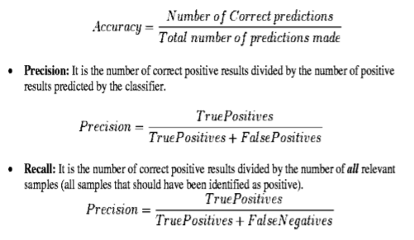

Fig 4.8: Evaluating accuracy formula

## Flow chart

A flowchart is one of the seven basic quality tools used in project management and it displays the actions that are necessary to meet the goals of a particular task in the most practical sequence. Also called as process maps, this type of tool displays a series of steps with branching possibilities that depict one or more inputs and transforms them to outputs.

## 

Fig 4.9 Flowchart

**CHAPTER 6**

**SNAPSHOTS**

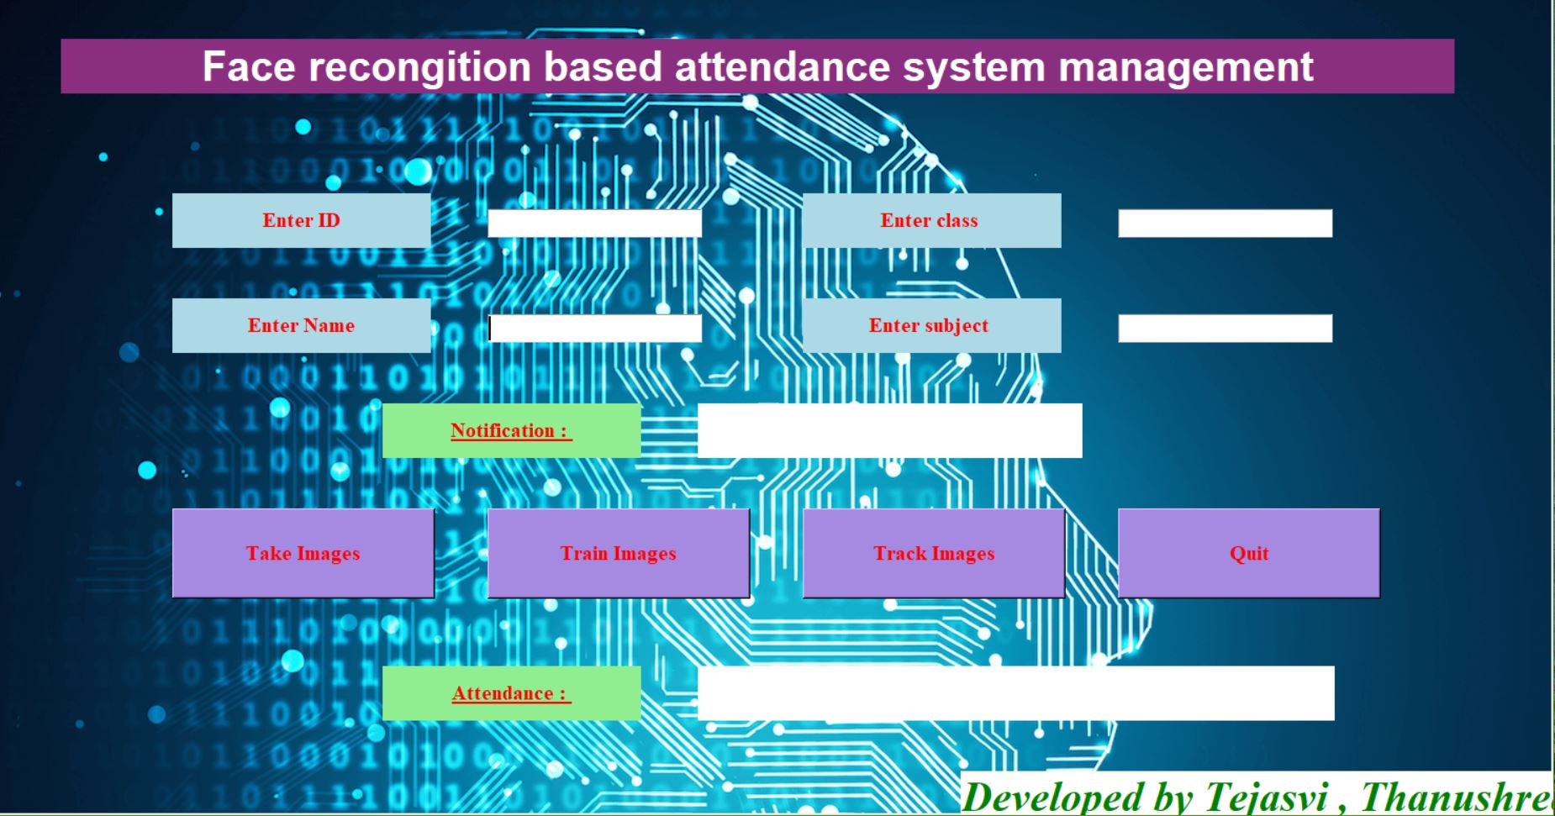

Fig 6.1 Main Interface

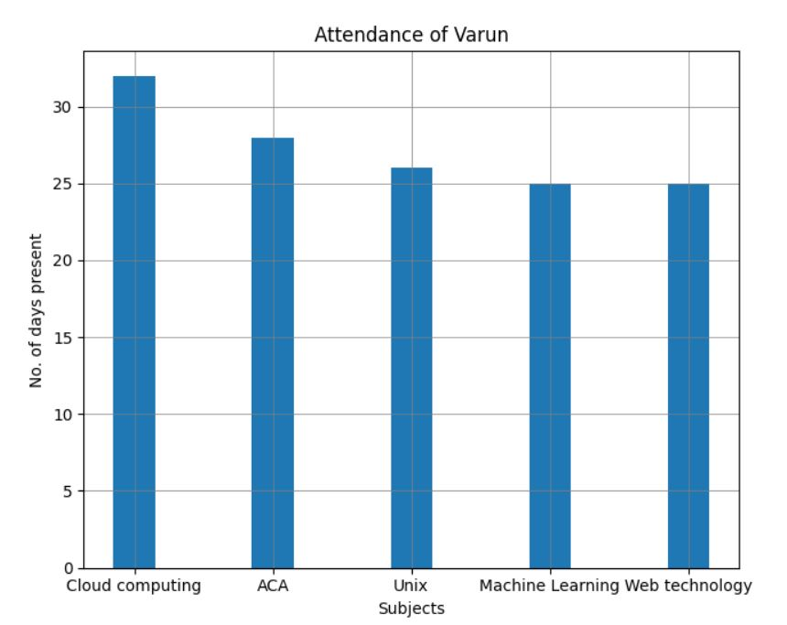

Fig 6.2 Bar graph

# CHAPTER 6

**SYSTEM REQUIREMENTS SPECIFICATION**

## Hardware Requirements:

* + - System : Pentium IV 2.4 GHz.
    - Hard Disk : 500 GB.
    - Ram : 4 GB
    - Any desktop / Laptop system with above configuration or higher level

## Software Requirements:

* + - Operating system : Windows 7 / 8 / 10
    - Coding Language : Python
    - Software : Anaconda
    - IDE : Jupyter Notebook

**CONCLUSION**

A methodological approach of a framework that is necessary which combines the two frameworks in one platform that is by identifying the face of the student attendance details along with his marks grades and progress must come together in one form by aligning these two methodologies together this is the proposal of this paper the framework modes and methods can be described elaborately in the forth coming papers.

*REFERENCES*

[1].Soniya, Paul S, Singh L. A review on advances in deep learning[C]// IEEE Workshop on Computational Intelligence: Theories, Applications and Future Directions. IEEE, 2015:1-6.

[2] Shuo Yang; Ping Luo; Chen Change Loy; XiaoouTang,”WIDER FACE:A Face Detection Benchmark,” 2016 IEEE Conference on Computer Vision and Pattern Recognition (CVPR)Year: 2016 Pages: 5525 - 5533, DOI: 10.1109/CVPR.2016.596

[3] Sikender Mohsienuddin Mohammad, "AUTOMATION TESTING IN INFORMATION TECHNOLOGY", International Journal of Creative Research Thoughts (IJCRT), ISSN:2320-2882, Volume.3, Issue 3, pp.118-125, August 2015, Available at :http://www.ijcrt.org/papers/IJCRT1133463.pdf

[4] RR Nadikattu, 2016 THE EMERGING ROLE OF ARTIFICIAL INTELLIGENCE IN MODERN SOCIETY. International Journal of Creative Research Thoughts. 4, 4 ,906-911.

[5] Xiaofei He; Shuicheng Yan; Yuxiao Hu; Niyogi, P.; Hong-Jiang Zhang, IEEE Transactions on Pattern Analysis and Machine Intelligence, pp. 328 340, 2005.

[6] M. Turk and A. Pentland, Eigenfaces for recognition, Journal of Cognitive Neuroscience, 3(1), pp. 7186, 1991.

[7] Sikender Mohsienuddin Mohammad, "AN EXPLORATORY STUDY OF DEVOPS AND IT'S FUTURE IN THE UNITED STATES", International Journal of Creative Research Thoughts (IJCRT), ISSN:2320-2882, Volume.4, Issue 4, pp.114-117, November-2016, Available at :http://www.ijcrt.org/papers/IJCRT1133462.pdf

[8] H. Lu, K. N. Plataniotis, and A. N. Venetsanopoulos, Mpca: Multilinear principal component analysis of tensor objects, IEEE Trans. on Neural Networks, 19(1):1839,2008.

